**ITP ASSIGNMENT FREQUENCY COUNT OF ARRAY ELEMENTS INDIAN INSTITUTE OF INFORMATION TECHNOLOGY, ALLAHABAD Electronics and Communication Engineering Department**

Kriti Shukla (IEC2021067) Manya Agrawal (IEC2021068) Aswitha Sai (IEC2021069) Naman Suhane (IEC2021070)

**Abstract: In this paper we have devised an algorithm to count frequency of each element and print all. We have discussed time complexity of the algorithm.**

**1.INTRODUCTION**

To count frequency of each element we require two loops. One outer loop to select an array element. Second inner loop to find first duplicate element of the currently selected array element by outer loop. Run an outer loop from 0 to size.

**2*.*ALGORITHM**

**1**.Declare and initialize an array arr.

**2.**Declare another array fr with the same size of array arr. It is used to store the frequencies of elements present in the array.

**3.**Variable visited will be initialized with the value -1. It is required to mark an element visited that is, help us to avoid counting the same element again.

**4**.The frequency of an element can be counted using two loops. One loop will be used to select an element from an array, and another loop will be used to compare the selected element with the rest of the array.

**5**.Initialize count to 1 in the first loop to maintain a count of each element. Increment its value if a duplicate element is found in the second loop. Since we have counted this element and didn’t want to count it again. Mark this element as visited by setting fr[j]=visited. Store count of each element to fr.

**6**.Finally, print out the element along with its frequency.

**3*.*PSEUDOCODE**

**STEP 1:** Start

**STEP 2:** INITIALIZE arr []={1,2,2,1,3,3,5,3,1}

**STEP 3:** length=sizeof (arr)/sizeof (arr [0])

**STEP 4:** DEFINE fr[length].

**STEP 5:** SET visited =-1.

**STEP 6:** SET i= 0. REPEAT STEP 7 to 12 until i<length

**STEP 7:** SET count =1

**STEP 8:** SET j=0.REPEAT STEP 9 and 10 until j<length.

**STEP9**:If(arr[i]==arr[j])then

Count++

fr[j]=visited

**STEP 10:** j=j+1

**STEP 11:** if(fr[i]!=visited)thenfr[i]=count

**STEP 12:** i=i+1

**STEP 13:** PRINT “------------”

**STEP 14:** PRINT “Element|Frequency”

**STEP 15:** PRINT “------------”

**STEP 16:** SET i=0. REPEAT STEP 17 and 18 until i<length

**STEP 17:** if(fr[i]! =visited)

Then print (“frequency of the “”element is “”)

**STEP 18:** i= i+1.

**STEP 19:** PRINT “-----------”

**STEP 20:** RETURN 0.

**STEP 21:** END

**4.** **RESULTANTOUTPUT**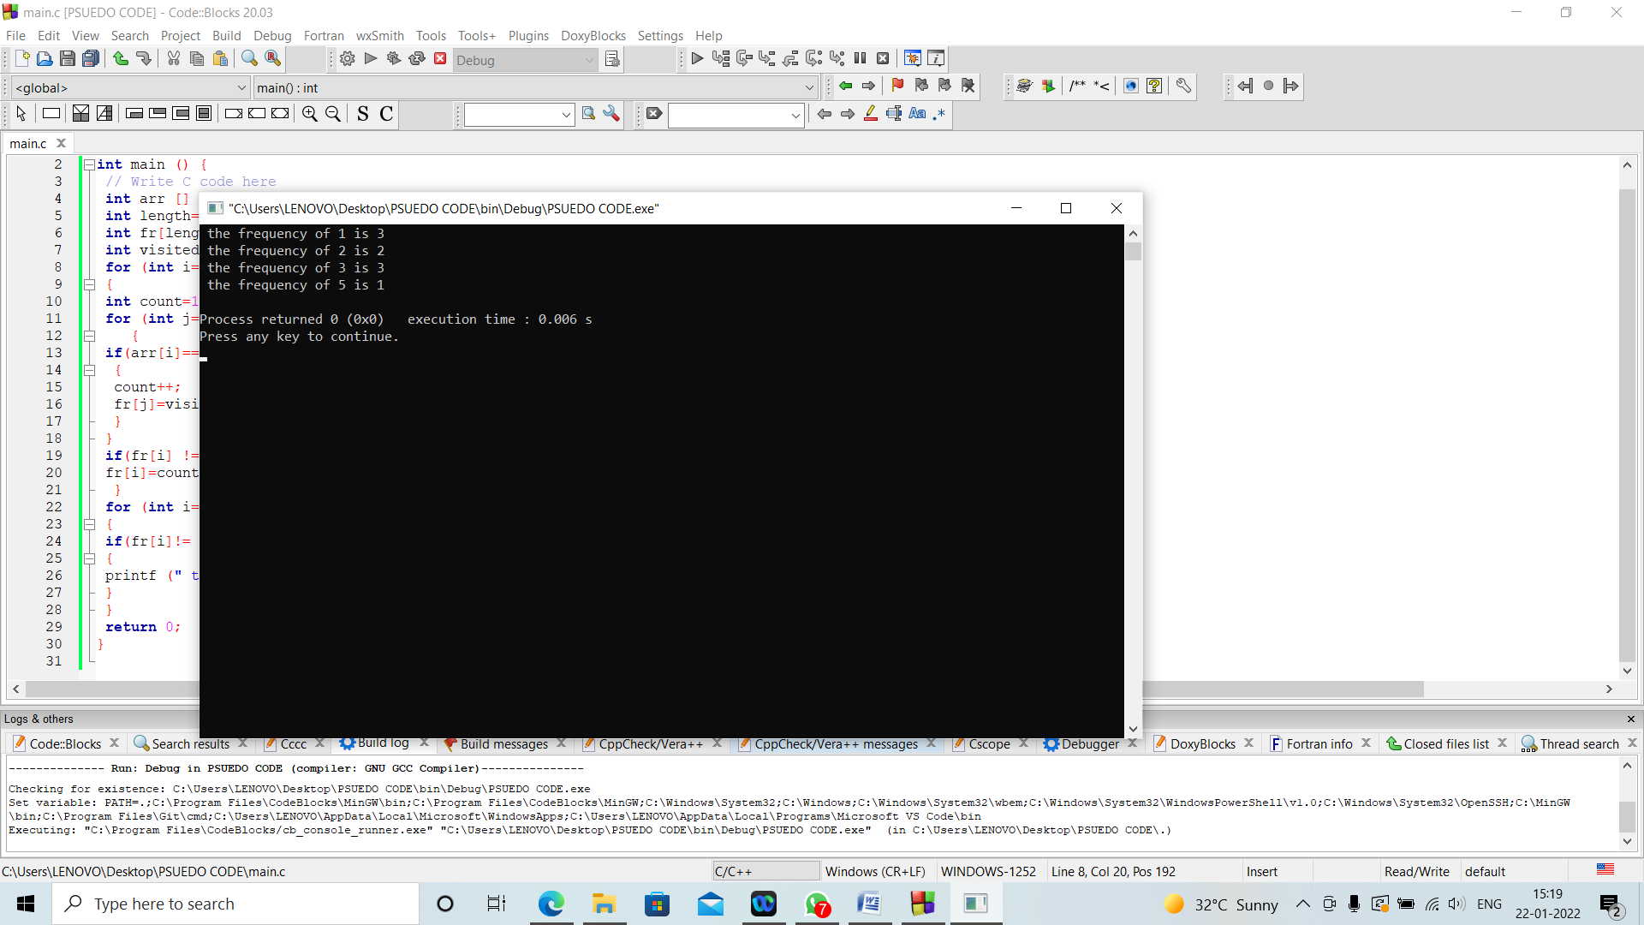

**5*.*TIMECOMPLEXITY**

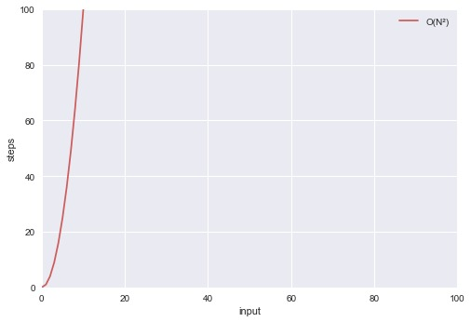

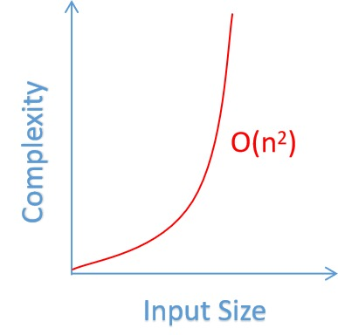

The time complexity of above devised algorithm is O(n2).

**6*.*CONCLUSIONS**

We can conclude that, using the above algorithm we can take a set of numbers and know the frequency of every element. To avoid counting frequency of same element again we marked the duplicate element ‘-1’ whenever we found as it saves memory and time of compilation.

**7*.*REFERENCES*:***

<https://www.geeksforgeeks.org/counting-frequencies-of-array-elements/>

**APPENDIX:**

